**ABSTRACT**

Health insurance is crucial for patients to afford high-priced healthcare services, whether provided by government or private systems. Unfortunately, some healthcare providers exploit this dependency by committing insurance fraud, resulting in significant financial losses for insurance providers each year. This paper addresses the challenge of detecting fraudulent claims using minimal claim data—specifically.

In summary, this paper introduces an innovative approach to detecting healthcare insurance fraud by leveraging minimal claim data and advanced representation learning techniques. The proposed methods, including MCC, LSTM networks, and RPCA extensions, demonstrate effectiveness in identifying fraudulent records, offering potential benefits for insurance providers in mitigating financial losses due to fraud.

**INTRODUCTION**

The significance of data analytics spans across various sectors, with healthcare being a prominent area due to its substantial economic impact in the US. The abundance of healthcare data, encompassing monitoring systems is imperative for accurately pinpointing the genesis and hypocenters of seismic events. Rapid and dependable characterization of active earthquakes poses a significant challenge in seismic hazard mitigation technologies like earthquake early warning (EEW) systems.

Traditional approaches to constructing EEW systems struggle with real-time hypocenter localization due to the limited early-phase data availability. Addressing this challenge requires refining hypocenter location estimates using minimal data from the initial seconds post-P-wave arrival and the first activated seismograph stations. Timeliness remains a critical aspect of EEW systems.

To tackle the localization problem, recurrent neural networks (RNNs) prove beneficial in managing sequential seismic station activations following the paths of seismic waves. RNNs effectively parse input data sequences to extract pertinent information, enhancing detection and source characteristic classification. Various machine learning-based methods have emerged for earthquake monitoring, including support vector machines, 6 decision trees, and convolutional neural network-based clustering techniques Regarding objectives, input design aims to streamline the transition from user-oriented data descriptions to computer-based systems, minimizing errors in data input and providing c1l2ear guidance for obtaining accurate data. Creating user-friendly data entry interfaces facilitates managing large data volumes while ensuring error-free data input and offering record-viewing capabilities. Validity checks are conducted post data entry, with notifications provided as needed to maintain user orientation and ensure simplicity in input design. In conclusion, our approach using limited data, with a focus on diagnosis and procedure codes, probabilistic topic modeling, and extensions using LSTM and RPCA. We provide novel contributions to the field and demonstrate improved comprising problem formulation, representation learning, and solution methodology, will catalyze further research into fraudulent claim detection utilizing minimal yet conclusive data.

**LITERATURE REVIEW**

1. In this paper, Haque and Tozal focus on healthcare fraud identification, emphasizing its detrimental impact despite being perpetrated by a minority of providers. Their proposed solution, termed BiGFuzzE, leverages to translate relationships between codes. They also explore an extension of BiGFuzzE utilizing vector representations of clinical codes instead of non-negative matrix factorization (NMF). Their experimental results highlight significant outcomes in fraudulent claim identification.
2. Wang provides an overview of digital finance anti-fraud, acknowledging the rise of digital financial technology and its accompanying fraud risks. The behavior-based anti-fraud paradigm is highlighted as an effective approach in digital finance, emphasizing the need for innovation and continuous authentication. The book proposes anti-fraud engineering, aiming to enhance behavior data and improve fraud prevention.
3. Mary and Claret address healthcare insurance fraud detection, emphasizing the importance of detecting fraud across multiple patient visits. Their proposed Provider Fraud Anomaly combines to enhance fraud detection. The framework incorporates preprocessing using a Relative Risk-based MapReduce framework and classification using a Recurrent Neural Network (RNN) with improved Decisional Score-based Bayesian Optimization (DS_BO). Experimental results demonstrate the superiority of the proposed framework in terms of accuracy, precision, recall, and computational time.
4. The paper authored by Shetty, V S, and Mahale comprehensively reviews multimodal medical data analysis, highlighting its significance in the context of the expanding medical data landscape and in healthcare systems. The acquisition pictures, and clinical records has necessitated the utilization of machine learning and deep learning methods for effective analysis. The paper focuses on radiology medical data analysis techniques, outlining different approaches and frameworks for representation and classification. It aims to identify gaps in current research and delineate future tasks in radiology. The study employs the Meta-Analysis (PRISMA) guidelines for article search and analysis of relevant scientific publications, conducting a systematic review on multimodal medical data analysis to highlight its advantages, limitations, and strategies. The paper emphasizes the impact of multimodality in the medical domain, particularly in disease diagnosis frameworks, when combined with artificial intelligence.
5. **2.1 EXISTING SYSTEM**

○ To risks, e3arthquake required to promptly provide before the arrival of damaging S waves. Deep learning algorithms present an opportunity to extract earthquake source information directly from complete seismic waveforms, bypassing the need for seismic phase picks.

○ We have developed a novel deep learning-based EEW system capable of e9stimating while simultaneously detecting earthquakes using. Upon receiving earthquake signals at a relatively small number of stations, the system swiftly computes the earthquake's location and magnitude, refining the solutions with ongoing data collection.

○ We applied this technique to the initial week of aftershocks following Remarkably, earthquake locations and magnitudes can be accurately estimated as early as 4 seconds after the initial.

○ - The current method does not explore existing system approaches to enhance real-time earthquake detection and classification of source characteristics.

○ - Convolutional neural network-based clustering m16ethods are not utilized for regionalizing earthquake epicenters or predicting precise hypocenter locations.

**2.1.1 Disadvantages**

The provided list enumerates several fraudulent activities commonly observed in the healthcare domain:

establishing fictitious diagnoses to support unnecessary medical treatments. pursuing medically needless procedures in order to get insurance reimbursement. "Unbundling" is the practice of billing for each phase of a procedure as if it were a distinct procedure.

Misrepresenting non-covered We applied this technique to the initial week of aftershocks following. Remarkably, can be accurately estimated as early as 4 seconds after the initial

**2.2 Proposed System**

The system utilizes to propose an RFbased approach for earthquake localization, as depicted in Figure 1. Specifically, it focuses on the initial recording stations. This emphasis on swift response to initial arrivals during earthquakes for the rapid dissemination of EEW alerts. Moreover, our approach integrates source-station locations into, implicitly considering velocity structures. Our approach, we leverage a comprehensive Japanese seismic catalogue. Our test results demonstrate the RF model's capability to accurately locate earthquakes even with limited information, offering efficient machine learning methodologies.

**Advantages of our approach include:**

The importance of as stricter requirements for simultaneous recording reduce the availability of eligible events. This is pertinent as our RF model utilizes from numerous stations as input. Leveraging the sequence of detected waves and seismograph station locations triggered by ground shaking to address the localization problem.

The utility as a valuable network architecture for handling

sequentially triggered seismic stations, effectively extracting information 2 from input data sequences.

**SYSTEM DESIGN**

**3.1 SYSTEM ARCHITECTURE**

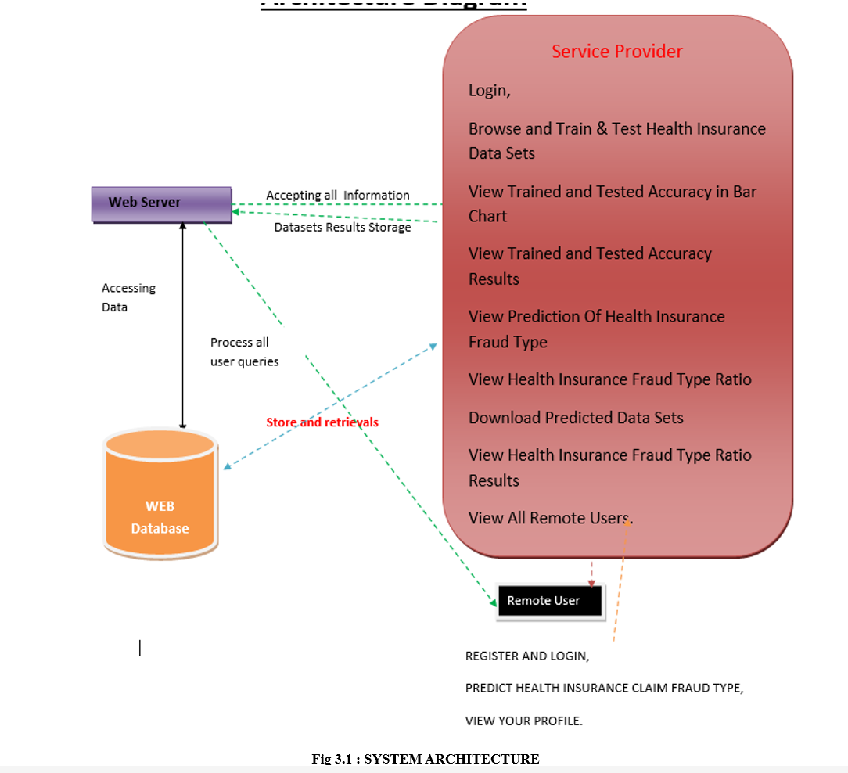

**3.2 Algorithms:**

**3.2.1 Logistic regression Classifiers**

The provided text discusses logistic regression analysis, focusing on its application in modelling categorical dependent variables with two or more unique values. It contrasts 46 logistic regression with discriminant analysis, highlighting logistic regression's versatility and

suitability for not normally distributed. Overall, the text provides an overview the capabilities of the described program.

**3.3 MODULES**

**3.3.1 Service Provider**

The module allows the Service Provider to log in using a valid username and password. Upon successful login, the provider can perform various operations including browsing, training, and testing health insurance datasets. Additionally, they can view the accuracy of trained and tested data in bar charts, as well as access detailed accuracy results. The module also enables viewing predictions of health insurance fraud types, analyzing fraud type ratios, and downloading predicted datasets. Furthermore, it provides insights into fraud and allows for viewing all remote users.

**3.3.2 Views of this**

Within this module, the administrator is granted access to the roster of registered users. Here, the administrator can peruse user information encompassing usernames, email addresses, and physical addresses. Moreover, the administrator possesses sanction users, thereby managing their access privileges.

**3.3.3 Remote User**

In this module, a system accommodates a multitude of users, each required to register prior to engaging in any activities. Upon successful registration, user details are stored in the system's database. Subsequently, users are prompted to log in using their authorized username and password. Upon successful login, users gain access to several functionalities, including registering and logging in, predicting health insurance claim fraud types, and viewing their profile.

**3.4 Study of Feasibility**

A study assesses the practicality of a project or system by conducting an objective and rational analysis of a potential business or venture. It aims needed and of success. Feasibility is judged based on two criteria: the cost involved and the expected value.

**3.5 UML Diagrams Introduction**

1. Unified Modelling Language is known as UML. An industry-standard universal design tool used in object-oriented software engineering is called UML. The Object Management Group developed and oversees the standard.

2. The intention uses UML to spread as a common tongue for modelling object-oriented software. The two primary UML components as it exists now are a notation and a metamodel. In the future, a process or approach might also be connected to or added to UML.

3. A common language for business modelling and other non-software systems, as well as for defining, visualising, building, and documenting software system artefacts, is called the Unified Modelling Language.

4. The UML is an assembly of top engineering methods that have 13 been effectively implemented to the modelling of complicated and sizable systems.

5. Creating objects-oriented software and the software development process both heavily rely on the UML. The UML primarily expresses software project design through graphical notations.

**3.5.1 UML Diagram:**

The software industry is searching for ways to automate software creation, enhance quality, lower costs, and shorten time-to-market as software's strategic importance to many businesses grows. Patterns, frameworks, visual programming, and component technology are some of these methods.

Ways to control the complexity of systems as 15 5 they grow in size and scope. They understand the necessity to provide solutions for reoccurring architectural issues including, concurrency, and physical distribution.

To meet these objectives, the Unified Modelling Language (UML) was created. Systems design, put simply, is the act of specifying the architecture, parts, modules, interfaces, and data predetermined requirements. This may be accomplished with ease using UML diagrams. Within the following list of four fundamental UML has been explained.

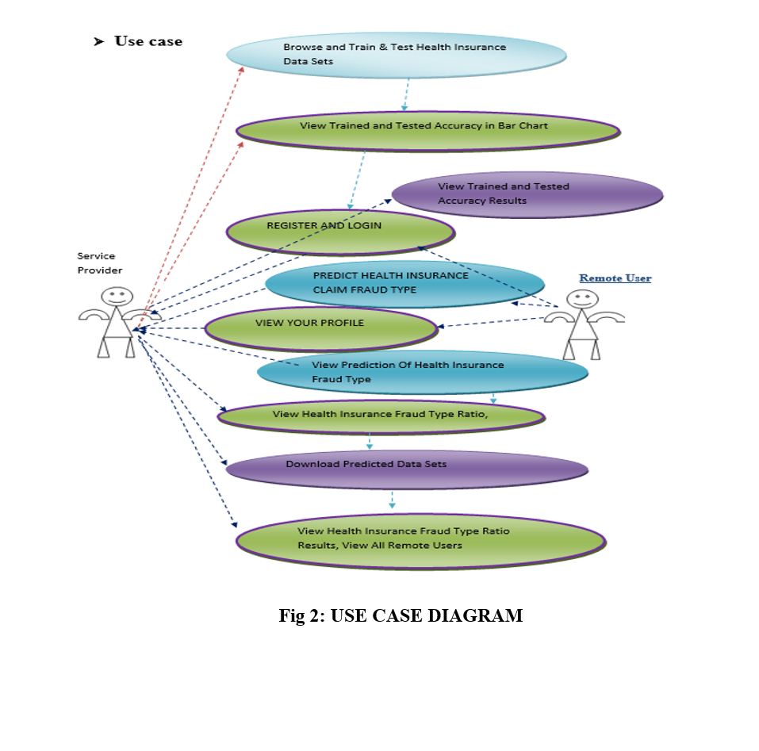

**3.5.2 Class diagram:**

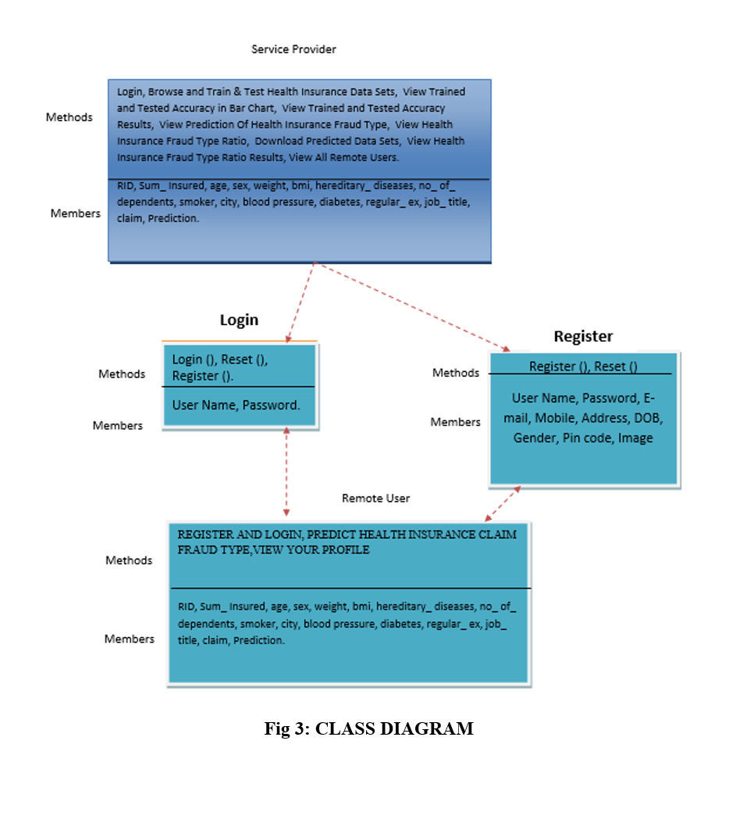

**3.5.3 Sequence diagram**

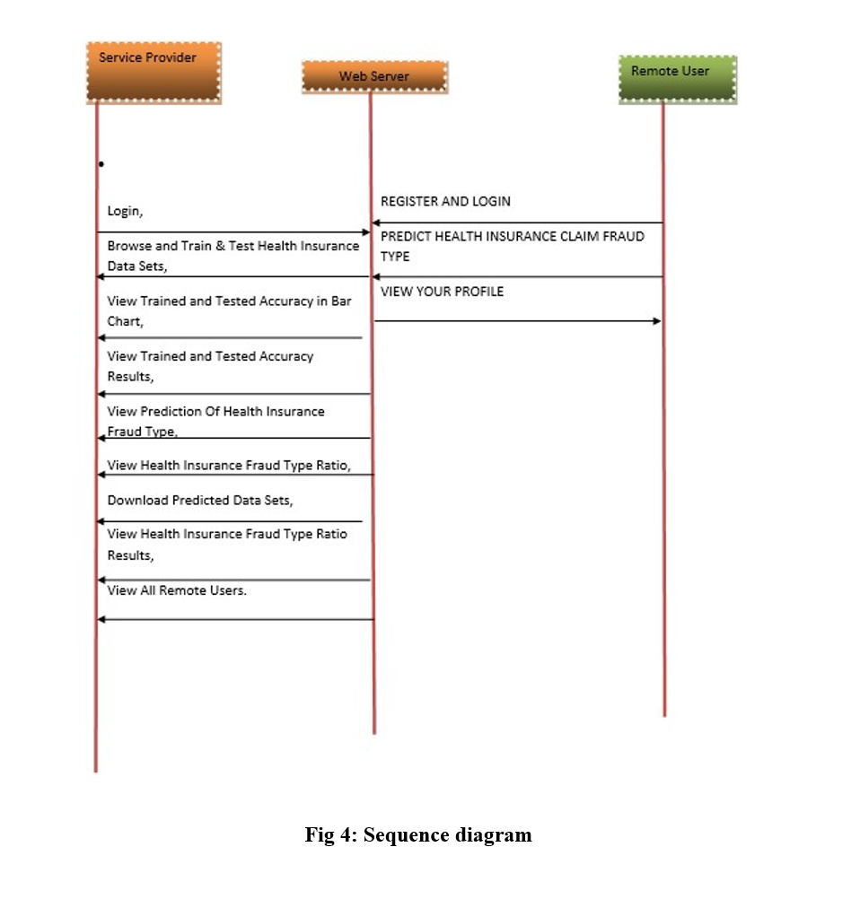

**IMPLEMENTATION**

Software development's implementation phase involves converting design specifications into source code. Writing source code internal documentation is the main objective of implementation since it makes it simple to verify that the code complies with specifications and eliminates the need for testing, debugging, and adjustments. To this end, we try to make the source code as simple and understandable as we can. The qualities of excellent programmes are their simplicity, clarity, and elegance. Cleverness, complexity, and obfuscation are signs of poor design and misguided thought.Source code clarity is enhanced by strutted techniques, by good coding style, by appropriate documents, by go internal comments, and by the features provided in the modern programming languages.

Since structured coding makes it possible to comprehend programme behaviour by reading the code from start to finish, its primary goal is to conform to single entry, single exit constructions in most cases. Strict adherence to this design raises questions about the code's efficiency in terms of time and space, which could lead to issues. Programmes with a single entrance and exit may occasionally need to call subroutines repeatedly or repeat code parts. Using this construct in these situations would stop premature loop exits and code branching to handle exceptions. Therefore, even while our goal is not to promote bad coding style, there are times when we must violate this notion in order to accept the realities of implementation.

Coding style in computer programming is demonstrated by the patterns programmers use to convey a desired action or result. While poor coding style can undermine the purpose of an outstanding language, good coding style can overcome the shortcomings of primitive computer languages. Simple, elegant code that is easy to understand is the aim of good coding style.

Effective coding practices accomplish the following Don'ts

• Give the model entities in the problem domain access to user-defined data types.

• Adhere to a small number of criteria and control statements.

• Place data structures behind functions used for access.

• Apply gotos in a methodical manner.

• Keep machine dependencies separate within a few processes.

• To improve readability, surround comment blocks with borders, indentation, parenthesis, and

blank lines.

• Carefully examine the routines having fewer than 5 or more than 25 executable statements.

**The following are the Don’ts of good coding style**

• Avoid null then statements.

• Don’t put nested loops very deeply.

• Carefully examine routines having more than five parameters.

• Don’t use an identifier for multiple purposes.

Adherence implementation standards and guidelines by all programmers on a project result in a product of uniform quality. Standards were defined as those that can be checked by an automated tool. While determining adherence to a guideline requires human interpretation. A programming standard might specify items such as:

• The nested depth of the program constructs will not execute five levels.

• The go to statements will not be used.

• Subroutines lengths will not exceed 30 Lines.

The ensuing goals guided the implementation process.

• Reduce the amount of memory needed.

• Optimise output clarity or readability.

• Increase how readable the source text is.

• Reduce the quantity of statements from sources.

• To make programme modification easier.

• To make official programme verification easier.

• To implement the tested system with the least amount of expense, risk, and annoyance to the user.

All baselined work items from the analysis and design phases are included in the supporting documentation for the implementation phase.

**TESTING**

**Functional Testing**: This involves systematically demonstrating the tester’s functions according to technical and business requirements, system documentation, and user guides. It focuses on valid input approval, rejection of invalid input, specified functions, application output classes, and interface systems/procedures. Testing is organized around requirements, important functions, and unique test cases, with a thorough assessment before completion.

**System Testing**: The integrated software meets the required standards. It verifies configurations and integration points based on process descriptions and flows to guarantee reliable outcomes.

**White Box Testing:** This method involves testing the internal structures and workings of a program, used for areas not accessible through testing.

**Black Box Testing:** Tests the software without knowledge of its internal workings. It relies on specification or requirements documents, generating inputs and reacting to outputs.

**Testing Methodologies**: These include Unit Testing (the smallest software units), Integration Testing (ensuring integrated modules work as intended), User Acceptance Testing (ensuring the system meets user needs), Output Testing (validating system outputs), and Validation Testing (checking data fields for accuracy).

**Unit Testing**: Verifies individual modules for error detection and coverage, ensuring each module operates correctly before integration. Integration Testing: Addresses verification and program construction issues, using unit-tested modules to build a program structure that adheres to design specifications.

**User Acceptance Testing**: Continuously tested for user acceptance during development, ensuring an easy-to-use interface for all users.

**Output Testing**: Ensures the system produces the necessary output in the correct format, either

on screen or printed.

**Validation Checking**: Tests fields like text and numeric fields for correct data entry, ensuring

each module meets required functionality with sample data tests.

**Test Data Preparation:** Involves using both live and artificial test data to thoroughly test the system, with real data providing realistic scenarios and artificial data testing various combinations of formats and values.

**User Training**: Essential for informing users about the new system’s functions, ensuring they

can use it effectively.

**Maintenance:** Covers fixing coding and design flaws, incorporating future technological advancements system meets user requirements for easier 11 maintenance.

**Testing Strategy:** A systematic sequence combining design methodologies and test cases, involving test planning, design, execution, and evaluation to confirm system functionalities and source code implementation. It software quality assurance, ensuring the system.

**Multi-Source Fusion:** Exploring m10ethods for fusing information from multiple data sources, including seismic, geodetic, and geophysical data, using advanced fusion algorithms such as Bayesian networks or ensemble learning techniques, can improve localization accuracy and robustness by leveraging complementary information from diverse sources.

**Real-Time Model Updating**: Implementing mechanisms for real-time model updating and adaptation based on incoming data streams can enhance the resilience of the localization system to changes in seismic conditions or network configurations, ensuring continuous optimization

and performance improvement over time.

**User-Driven Feedback Mechanisms**: Incorporating user feedback mechanisms into the localization system, such as crowd-sourced ground truth data or user-reported event locations, can enable iterative refinement of the RF model and enhance its performance by learning from real-world experiences and user interactions.

**SCREENSHOTS**

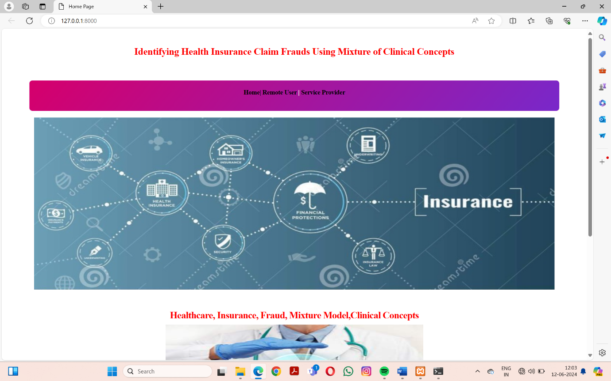

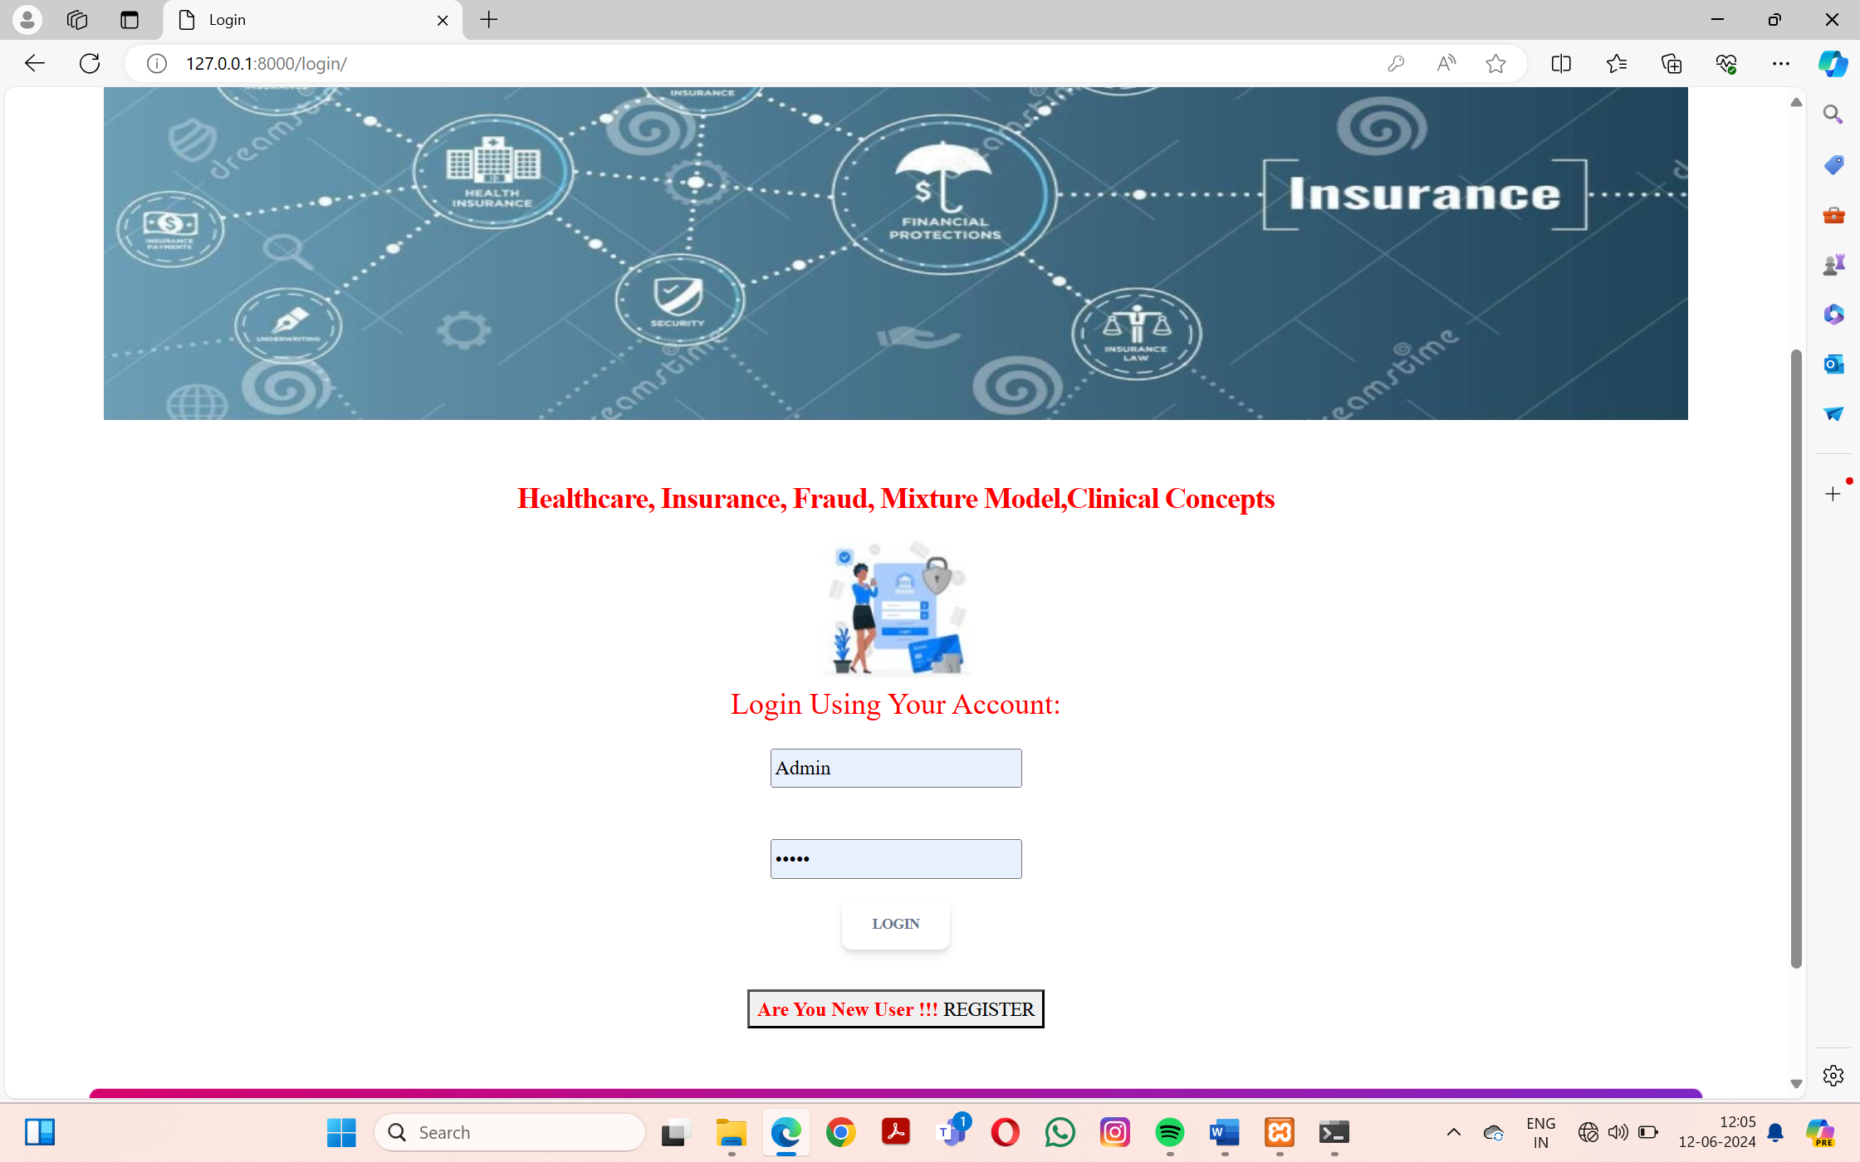

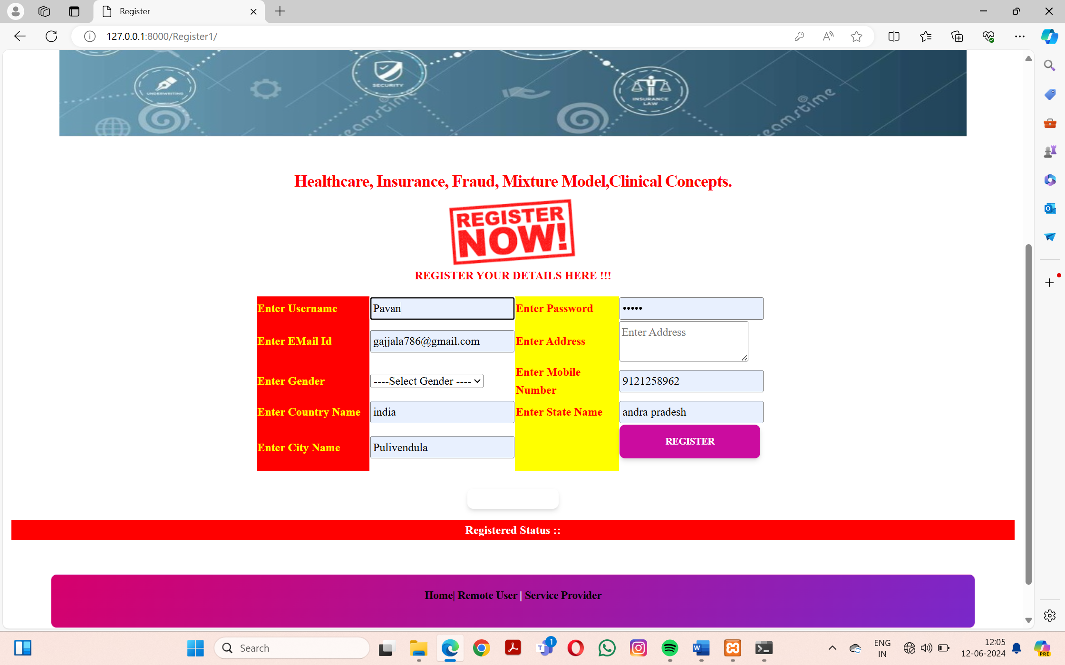

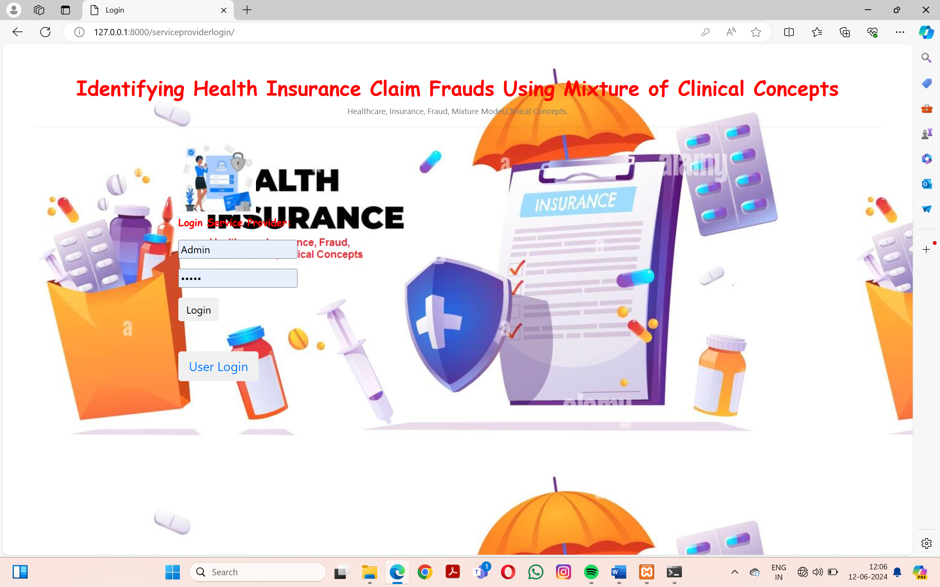

**CONCLUSION**

In this paper, we address the challenge of identifying fraudulent insurance claims by treating it as a process of feature generation and classification. We focus on a minimal yet definitive dataset of claim data, limited to procedure and diagnosis codes. This approach is taken because richer datasets are often restricted by legal issues and inconsistencies across various software systems. We propose a new representation learning method using codes. We hypothesize that each claim is a representation of latent or explicit mixtures of clinical concepts, which are themselves combinations of diagnosis and procedure codes.

To enhance the model, we incorporate Long-Short Term Memory networks (MCC + LSTM) and Robust Principal Component Analysis (MCC + RPCA) to extract significant concepts from claims and classify them as either fraudulent or non-fraudulent. improving the detection of fraudulent healthcare claims with minimal information. Both the MCC and MCC + RPCA models show consistent performance across different concept sizes and replacement probabilities in the generation of negative claims. The MCC + LSTM model achieves accuracy, precision, and recall scores of 59%, 61%, and 50% respectively on inpatient datasets. For outpatient datasets, it reaches 78% accuracy, 83% precision, and 72% recall. We observe similar results between MCC and MCC + RPCA models, both employing an SVM classifier. our proposed formulation, representation learning approach, and solution minimal, definitive data.